Assignment #8.02: Rotational Kinematics

- A pitcher throws a curveball that reaches the catcher in 0.5s. The ball curves because it is spinning at a rate of 5.5 rotations/sec on its way to the cather's mitt. What is the angular displacement of the baseball as it travels from the pitcher to the catcher?

- The earth spins on its axis once a day, and orbits the sun once a year (365.24 days). Determine the angular velocity for the earth as it -
  - spins on its axis

  - orbits the sun

- A figure skater is spinning with an initial velocity of 14π radians/second. She then slows down to a stop. Her angular displacement is 5.1π radians.
  - What is her angular acceleration?

  - What is the time it takes her to come to rest?

- A motorcycle starts from rest and accelerates to a speed of 24 m/s in a time of 9s. The radius of the tires is 0.28 m.
  - What is the final angular velocity of the tires?

  - What is the angular acceleration of the tires?

- An alligator can snap its jaws shut in as little as 1.1x10⁻⁴ s. During this time, the alligator's jaws rotate through an angle of 90°. What is the angular velocity of the alligator's jaws?

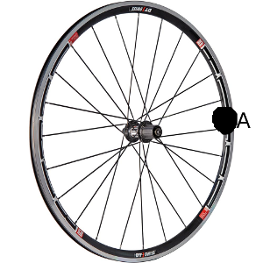
- You are looking at point A on the wheel. The wheel is rolling counterclockwise. It spins 10π radians in 2 seconds. Its radius is .3 m.
  - What is the arc-length (distance) that point a has traveled?

  - What is the rotational velocity of the wheel (speed and direction)?

  - What is the linear velocity of the wheel?

  - What is the time it would take the wheel to make 10 complete rotations?

  - How far does point A travel during that time? (Arc-length)

- A roulette wheel spins at an initial rate of 4.5 turns per second. Over the course of 12 seconds, it comes to a stop.
  - What is the angular acceleration of the wheel?

  - What is the total angular displacement of the roulette wheel?

